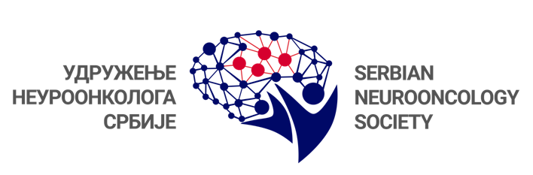

BRAIN TUMORS IN CHILDREN-SIGNIFICANCE OF HERITAGE
November 13, 2020. Hotel Crowne Plaza, Belgrade

Registration form
Surname: Name:
Licence number:
Titlle: Specialization:
Institution:
Address:
Phone:
E - mail:
Date of registration:
Registration form sholud be sent on: secretariat@unos.rs

REGISTRATION FEE: FREE

SECRETARIAT
ARIA Conference & Events d.o.o.
Karađorđev trg 34, 11080 Zemun
Tel. +381 11 2600.978
Fax. +381 11 2604.590

